Exp No: 29
PRIORITY-BASED INTERRUPT HANDLING
AIM:
To model priority-based interrupt servicing.
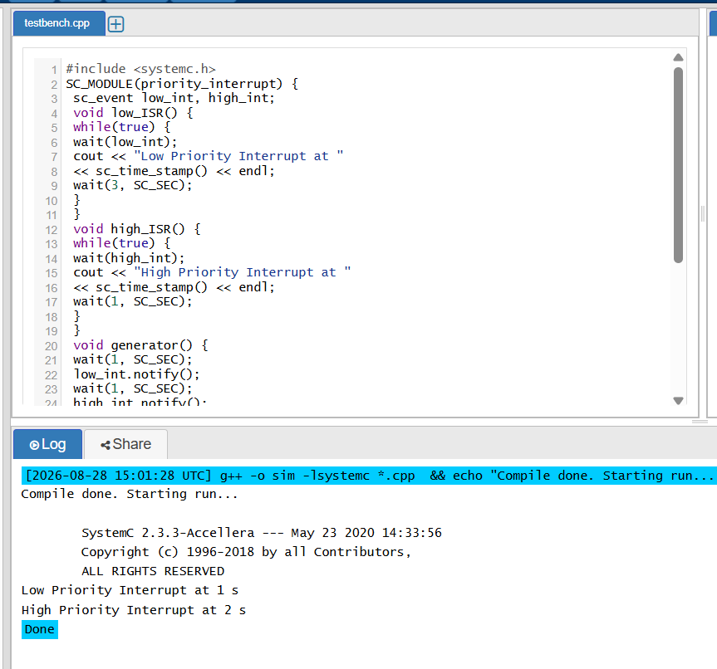
RESULT:
Thus the Priority based Interrupt handling was executed using SystemC and verified

